**Installation Guide:-  
As I have yet not created an apk file for android and ios to download the app, you will have to use the following steps to download the app:-**

1. **You need to have flutter installed and running on your device with all the extensions required for running the app like ruby and xcode with cocoeda, etc.**
2. **You need to connect a device either android or iOS to your laptop or create an emulator for doing this**
3. **Use the command flutter run in terminal to run the code and choose the device you want to run the code on**
4. **You wait and see the app getting Installed.**
5. **App is Installed for perfect use.**

**If you are still not able to get it installed contact me or refer to the details about app with screenshots given below.**

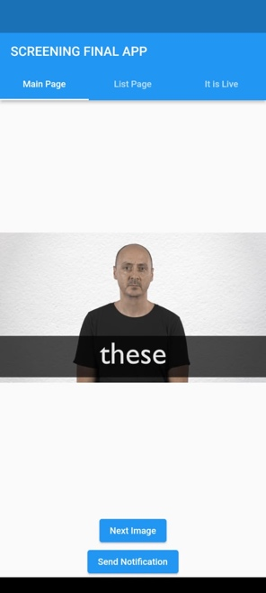 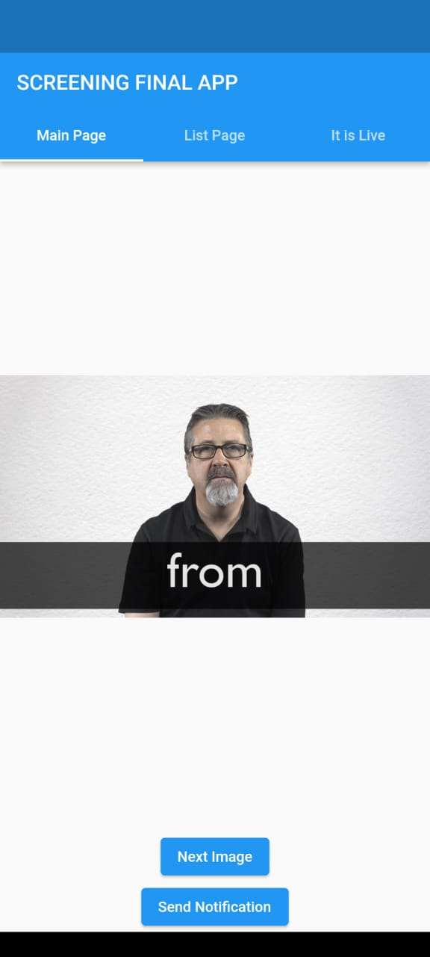

**1:-**

**These are 5 different images which have been loaded in this app from the internet and these images change as soon as we click on the “next image” button.**

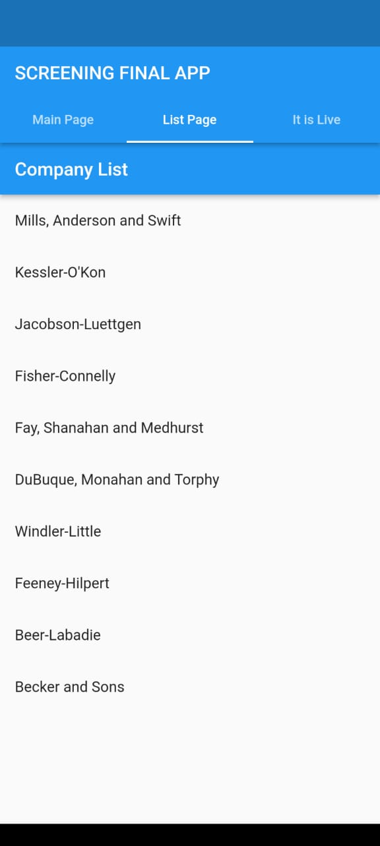

**2:- This section of the app Shows the list of companies those were provided in the API provided in the PS.**

**3:-This section Shows that this is live by using the Real time Data of Stocks of Apple I have used Alpha Vantage API for this data.**

**4:- By clicking on the Send Notification Button on the main page you get a desired notification on the device.**

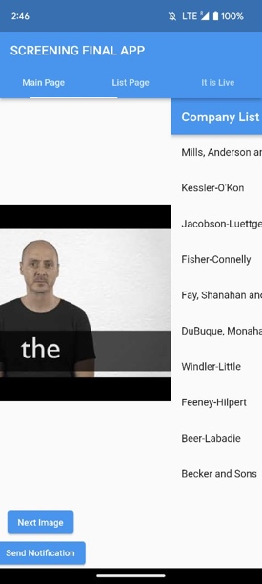

**This Image shows the navigation between the multiple screens, I have created multiple tabs which can be accessed by clicking on the tabs or by swiping to the right or left.**

**(for correct Coding Practices check my code on the GitHub link)**